**Direct Policy set up:**

1. Select Irish life policy from the drop down

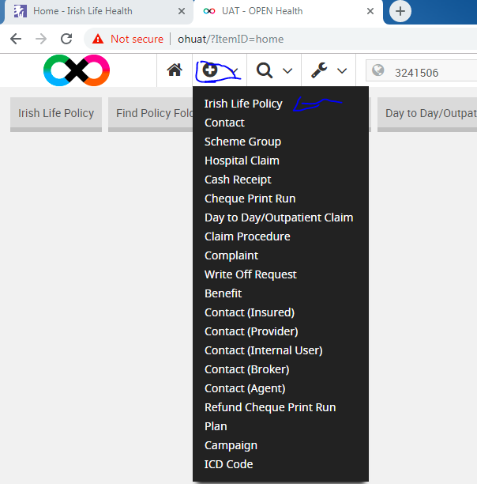

1. Complete all the fields which are highlighted in red

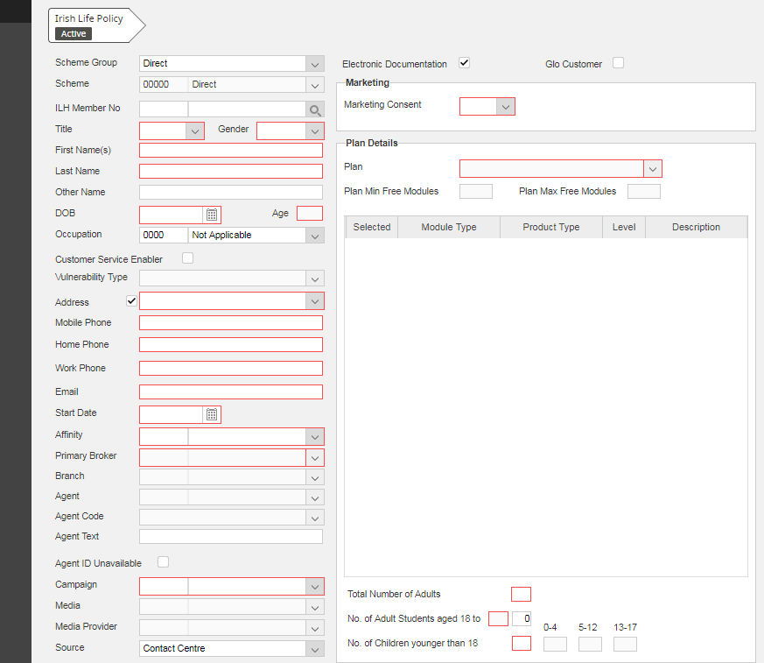

1. The above mentioned fields should be populated as shown in the below, for exception of address where you have to click on the plus button to complete the address



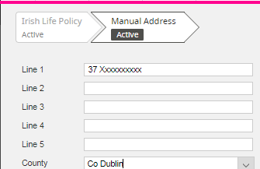

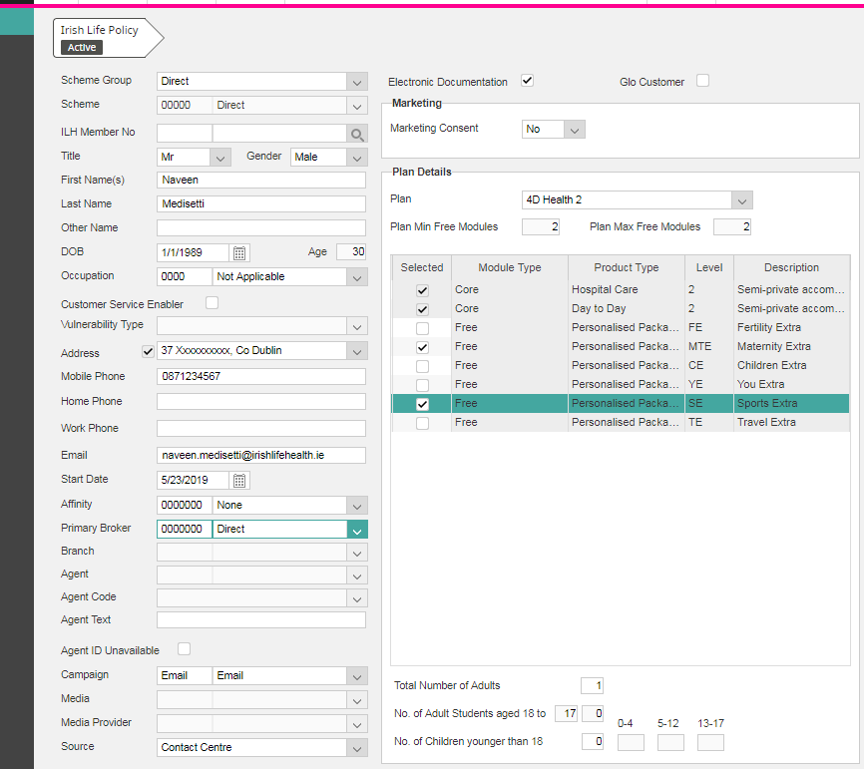

1. After populating all the details click the ok button and you will navigated to the below screen, here you can observe the policy in the submission state, now you have to make this policy live, to do this please follow below steps

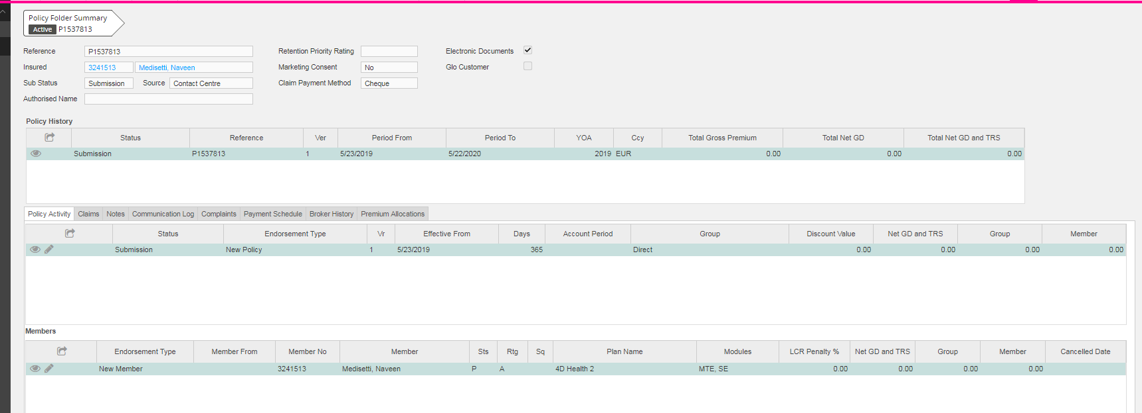

1. Click on the edit button in the policy activity section as shown below



1. You will navigated to the below screen and please click the edit button beside the members name

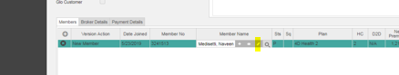

1. Now you are navigated to the below page and must populate the fields which are highlighted in the red and click ok

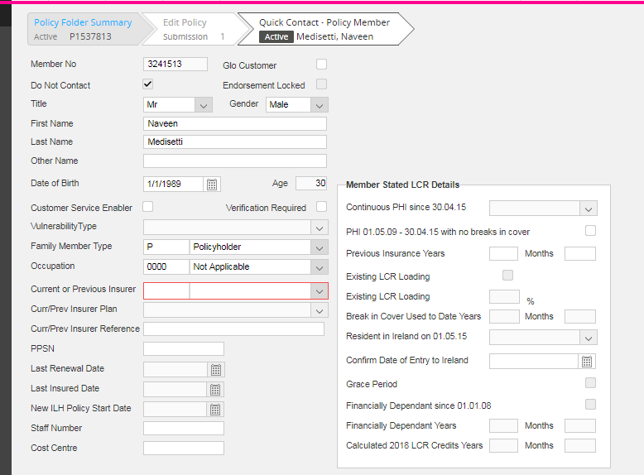

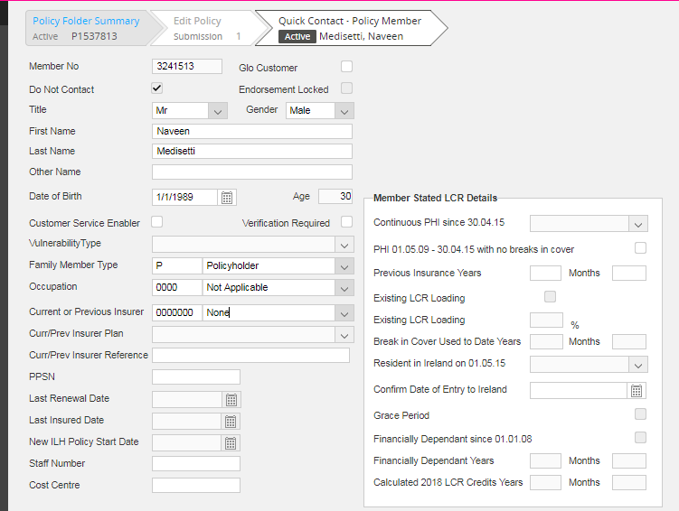

1. Now you will be navigated to the below page where you have to select payment details tab

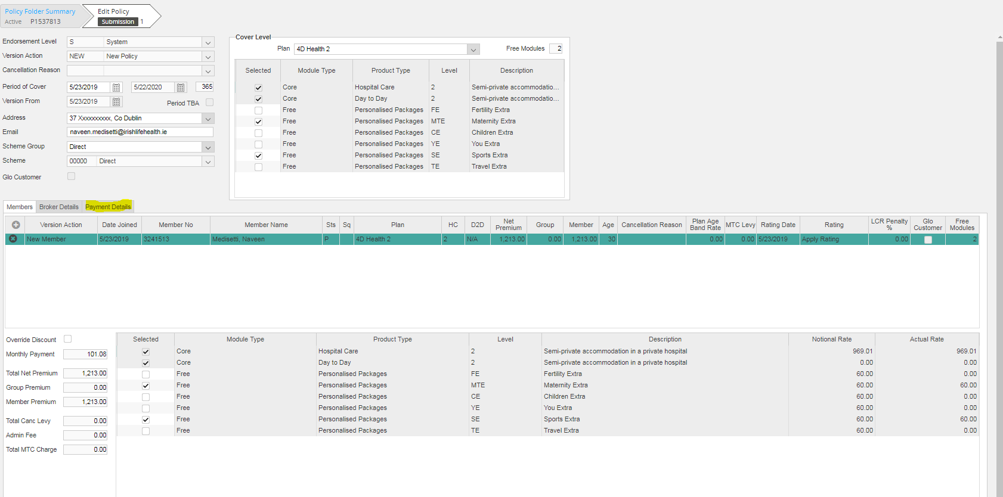

1. Now you are navigated to the payment section where you have to populate the fields as shown below, please note for testing purposes we select mainly cheques, you can also select DD as well

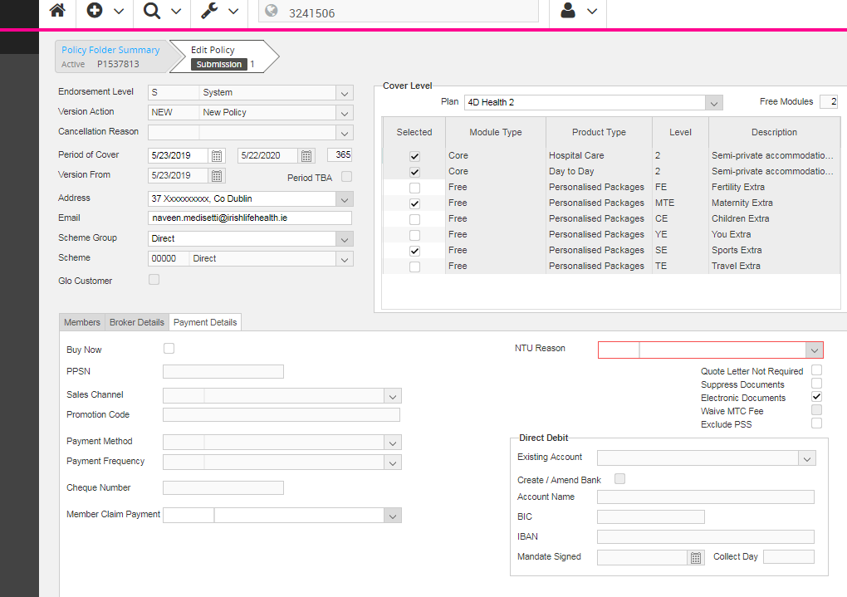

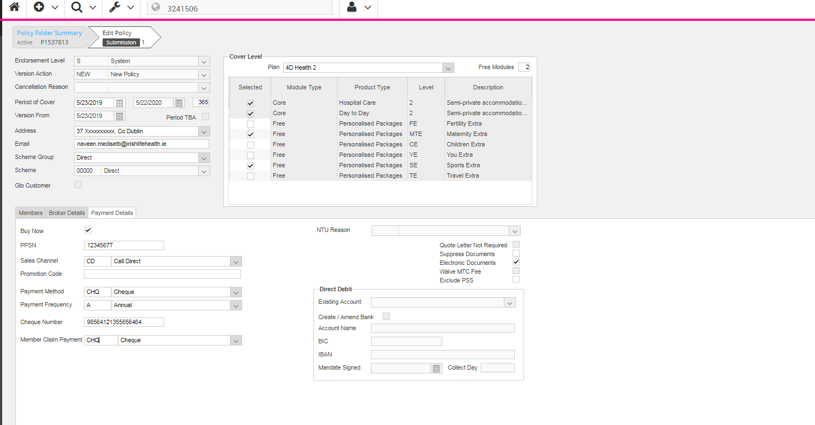

1. Now the policy status is live

